MANAGERIAL AGREEMENT
Jackson County
(All Animal Science Projects)

Objectives:
- To develop character, knowledge, and a sense of responsibility in 4-H youth.
- To maintain or increase the number of youth carrying a 4-H animal science project.
- To maintain or increase the number of animals carried as 4-H projects.
- To provide the opportunity to work with animals for both non-farm youth and youth from farms with different species of animals.
- To increase the credibility of Jackson County managerial projects.

Name ___________________________________________ Grade as of September _______
Address _________________________________________ Phone Number ______________
Name of 4-H Club ____________________________________________________________
Description of animal(s) you plan to manage (be specific i.e. species, breed, age, etc.) ______
___________________________________________________________________________
Name and address of owner ____________________________________________________
___________________________________________________________________________
Location where animal(s) will be housed __________________________________________
Date Managerial Agreement will begin ____________________________________________

Note: Animal(s) should be managed for at least 3 months prior to the date of the fair.

Describe your involvement in the management of the above animal(s). Please include what you will be doing and how often you will do it. (Be specific i.e., 3 days/week)
Feeding: ___________________________________________________________________
___________________________________________________________________________
Sanitation (cleaning stalls/pens): ______________________________________________
___________________________________________________________________________
Health Maintenance. Please include who will pay for vaccinations, health papers, etc.: _____
___________________________________________________________________________
Preparing animal(s) for show. Describe who will be training and fitting animal(s): _________
___________________________________________________________________________
Any other responsibilities you have which involve the above animal(s): ______________
___________________________________________________________________________
Do you plan to exhibit animal(s) at the Jackson County Fair? Yes No

Signature of General Leader ____________________________________________________

I agree to abide by this Managerial Agreement:
Member’s Signature __________________________________________________________
Parent/Guardian’s Signature ____________________________________________________
Owner’s Signature ___________________________________________________________

Include this page in your Record Book.

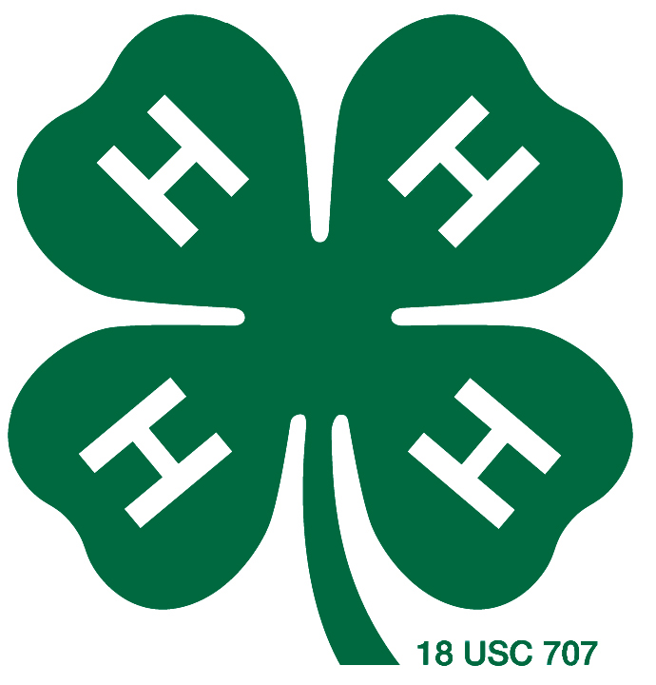
Adapted by Monica Lobenstein, Jackson County 4-H Youth Development Agent, 2010, “Taylor County Managerial Agreement.”

