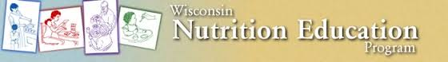

April Duval, Coordinator:

WNEP Projects & Events:

* State WIC Work Group – worked on updating 12 mini lessons state WNEP use in FY16.
* Northwest Regional Family Living Meeting.
* WNEP Coordinator Annual Review with State Liaison.
* School and Child Hunger Work Group WISline.
* Northwest Regional WNEP meeting.
* WNEP Coordinators Conference call
* Nutrition Educator Hiring Process – final interview September 29th. Main office location in Trempealeau County with educational events mainly in Trempealeau County.
* Kindergarten, 2nd Grade and 5th Grade lesson updates and modifications and organization or materials.

Educational Programming in Jackson County Community:

- Jackson County WIC: Eating the MyPlate Way with eWIC: 3 adults
- Jackson County Food Pantry: Taylor, WI : Fruits Mini Lesson:
2 male, 9 females, 11 total adults

April had a total of 2 Nutrition Education events in Jackson County
with a total of 14 educational contacts from 9/1/15 – 9/30/15.

Upcoming WNEP Projects, Events & Programs for April in October:

- WNEP Fiscal Year 2016 starts October 1st
- End of Year WNEP Reporting paperwork and narrative.
- Jackson County WIC Mini Lessons: Healthy Food for Your Dollar
- Jackson County Early Head Start Home Based Families Parent Program Lesson.
- Jackson County Food Pantry: Taylor, WI x 2
- Beginning to Schedule lessons in schools – Black River Falls, Lincoln Elementary in Merrillan.
- Preparing for new Nutrition Educator to start.

~~~~~~~~~~~~~~~~~~~~~~~~~~~~~~~~~~~~~~~~~~~~~~~~~~~~~~~~~~~~~~~~~~~~
UW-Extension’s Wisconsin Nutrition Education Program (WNEP) is federally funded through the SNAP-Ed program and helps limited resource families and individuals:
- Choose healthful diets and be physically active.
- Handle food safety to avoid food-borne illness.
- Become more food secure by making food spending plans, planning meals, and using thrifty food shopping practices.

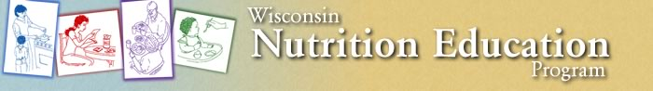
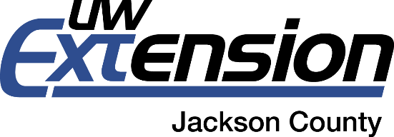
The Wisconsin Nutrition Education Program (WNEP) is major educational program within the UW-Extension Family Living Program. WNEP’s purpose is to help limited resource families and individuals choose healthful diets, purchase and prepare healthful food and handle it safely, and become more food secure by spending their food dollars wisely. Key topics include focusing on whole grains, eating fruits and vegetables, and making low fat dairy and protein choices.
WNEP is funded by federal dollars within the SNAP-Ed (Supplemental Nutrition Assistance Program Nutrition Education). Funds from this grant pay 100% of the salary and benefits, professional development, travel expenses, and most program costs for WNEP. Jackson County provides office space, phone and internet, paper, and copies, support staff, and tech support.
Limited income families or individuals and those who receive – or are eligible to receive- food stamps (Food Share) can learn through WNEP. WNEP reaches Jackson County youth in schools through classroom lessons during the school year. Nutrition Education occurs in Kindergarten, 2nd and 5th grade classrooms at schools whose population is at or above 50% free and reduced lunch. Adults participate in Nutrition Education at the Jackson County Food Pantry. Parents of infants and children participate at WIC.
Jackson County Year End Report for Fiscal Year 2015 (October 1, 2014 – September 30, 2015)
WNEP Nutrition Educators had 123 Nutrition Education Teaching Events in Jackson County with 1,874 direct teaching contacts. 1855 of those contacts were youth at Black River Falls Elementary (Kindergarten and 2nd Grade) and Lincoln Elementary (Kindergarten, 2nd and 5th Grade). Eight contacts were parents at Jackson County WIC and 22 were at the Food Pantry in Taylor, WI.
Goals for Jackson County WNEP in Fiscal Year 2016 (October 1, 2015 – September 30, 2016):
Increase parent nutrition education contacts.

Action Plan:
We have new agreements for Nutrition Education lessons with Jackson County Head Start parents. Continue mini lessons with Jackson County WIC clients.

