4-H Youth Development Team
October 2015 Highlights

4-H Outreach:
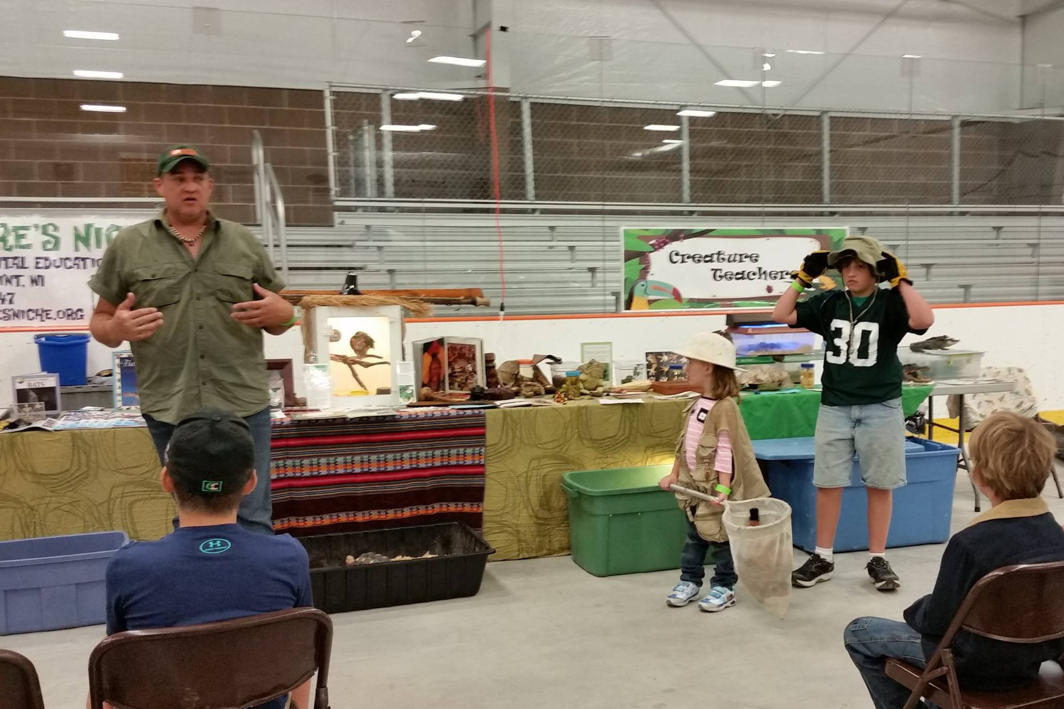
- GreenLifeXpo – Nearly 300 youth and adults participated in this year’s GreenLifeXpo at the Milt Lunda Memorial Arena on September 12. Five adult and three youth volunteers from 4-H helped at the event. Youth activities included 2 matching games about water usage and carbon footprint, a screenprinting activity and life-size Angry Birds. We also helped support the Nature’s Niche wildlife presentation which took place at 10AM and 1PM. Jackson County 4-H sold gourmet grilled sandwiches, walnut burgers, and homemade pickles at the event as a fundraiser.
- National 4-H Week – Alex worked with the radio station and 3 youth volunteers to record PSAs for the radio that are being played during National 4-H Week. Monica worked with several youth and adult volunteers to submit letters to the editor for both newspapers about their 4-H experiences. You should have been seeing the letters as well as articles from Monica for the past 3 weeks.

Volunteer Development:
- Record Books Judging – Eleven adult community members took part in Record Books Judging this year on Tuesday, September 15. After enjoying tacos for dinner, the group judged 13 Cloverbud Record Books and more than 30 record books and project records for youth in grades 3 and higher. Three of the participating youth accepted the challenge to create their books in the new eRecord Books format – using technology to build and present their record.

Strengthening Families:
- Strengthening Families – 6 families signed up for the Strengthening Families Program. Attendance has been a challenge that we’re hoping will improve over the next couple of weeks.
- Community Partnerships – Alex and Monica have met with a range of community partners over the last several weeks to solidify programming opportunities during the school year:
  - Lincoln HS – hosting TABO and Youth QPR; considering hosting Taking Care of You and MindUP
  - BRFHS – hosting TABO and Youth QPR; partnering with UWEX and TFJCK to offer peer educator training; considering hosting Taking Care of You and MindUP
  - Afterschool programs – BGCJC and BLAST are both willing to host MindUP during afterschool and Taking Care of You for parents
  - Dept of Health & Human Services – currently holding Taking Care of You sessions with staff members and plan to offer it in the community when they are finished.

Key Meetings:
9/9 – Animal Science Round Robin planning mtg; Livestock Education mtg
9/10 – Program Area Wisline, WPP grant financial webinar; HWPP planning mtg with MCW partner
9/11 – GreenLifeXpo preparation (Alex & Monica)
9/14 – TFJCK Leadership Team mtg; Youth Programs mtg with Lincoln HS staff (Alex & Monica)
9/15 – SQUAD mtg (tri-county mental health partnership); Took Rx drug abuse stickers to HCN Health Care Center (Alex)
9/16 – Regional 4-HYD meeting
9/17 – STEM Team Planning mtg
9/21 – Youth Programs mtg with BRFHS staff (Alex & Monica)
9/22 – State Teams review mtg
9/24 – Taking Care of You planning mtg; STEM Wisline; eForum webinar; CPAG meeting
9/28 – Staff mtg
9/29-10/1 – Association, State Teams and Foundational Topics mtgs
10/2 – Mindfulness Programs planning mtg

Trainings/Workshops Facilitated/Led:
9/12 – GreenLifeXpo (Alex & Monica)
9/15 – Record Books Judging
9/22 & 29 – Strengthening Families mtg (Alex & Monica)

