4-H Youth Development Team
Outdoor Adventure Hike
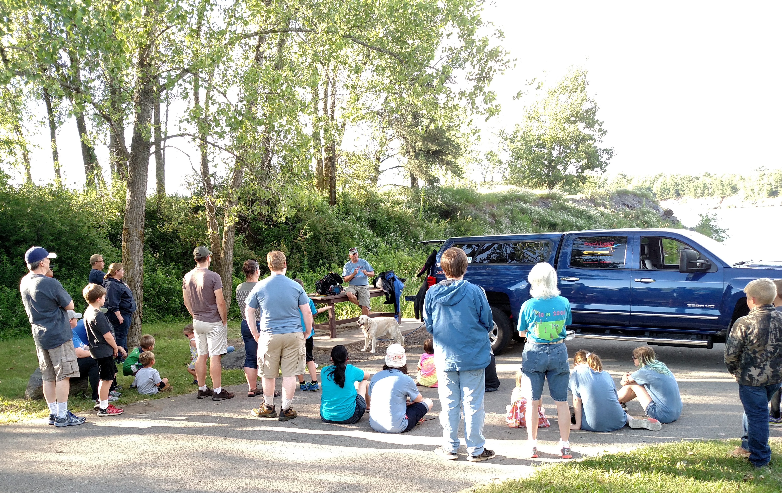
Keith Cormican explains the science of scuba diving.

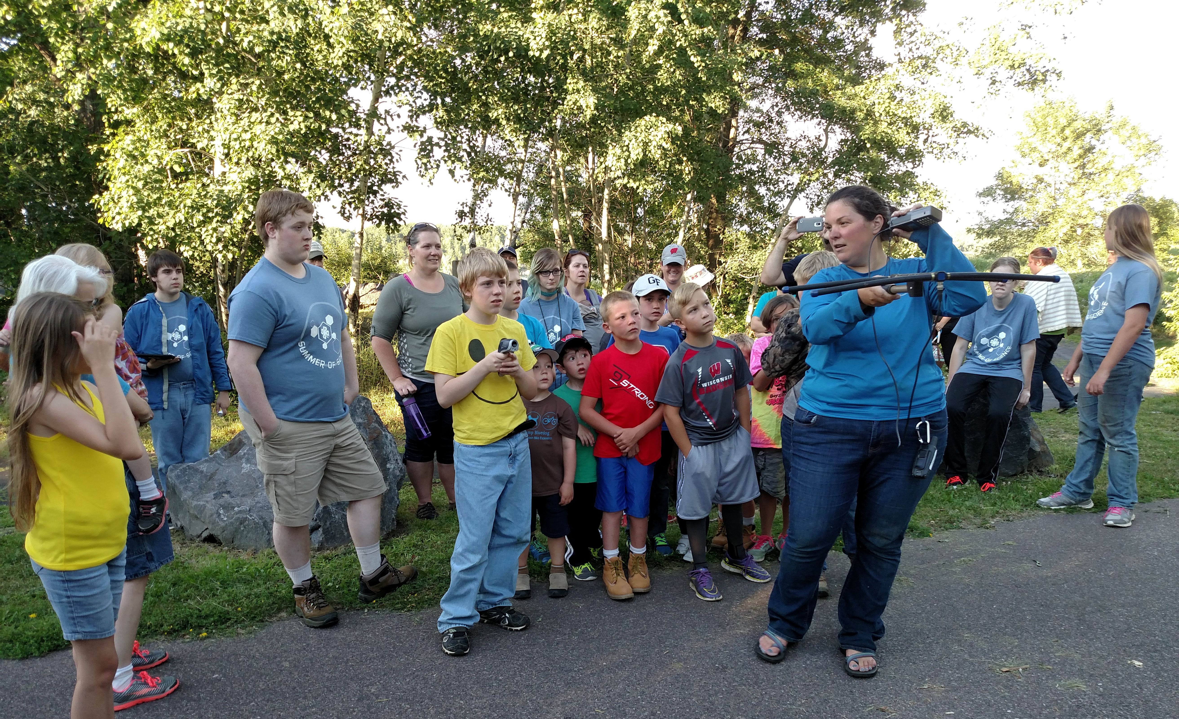
Karen Sexton teaches participants how to use a radio collar to track wolves

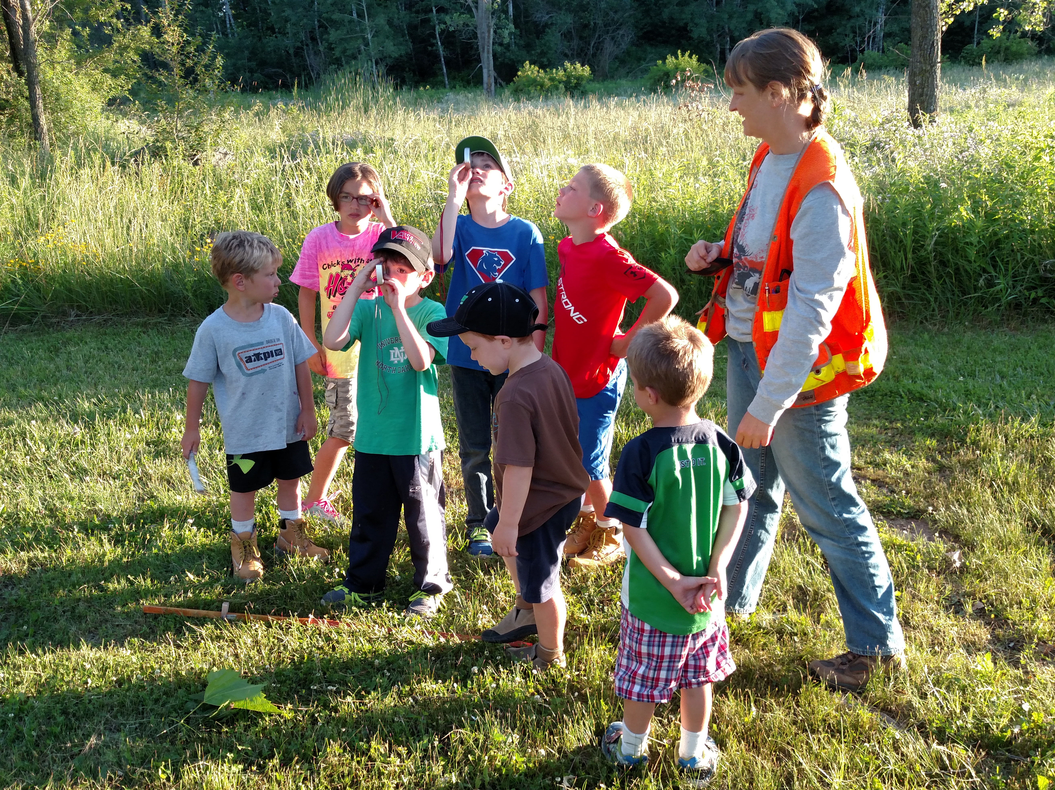
Jennifer Boice teaches participants how to determine the height of a tree using a clinometer.
July 2016 Highlights

4-H Outreach – Summer of Science Events:
- Soybean Science Events – 8 youth and 5 teen leaders participated in these events, learning how to make ink at one session and learning to make lip gloss and hand cream at the other. These products were all made from soybeans, stressing the importance of soybeans as an agricultural product.
- Moss, Moss, and More Moss – 6 participants conducted a science experiment to determine which material was most absorbent – cotton, sphagnum moss, or gel. They developed a hypothesis, conducted the experiment and observed the results. Then, Kim Rundle, a representative of Mosser Lee, taught them about sphagnum moss and led them through an activity in planting climbing plants with a sphagnum moss post.
- Outdoor Adventure Hike – 41 youth and adult participants, including 7 teen leaders, took part in a 1 mile hike with 4 stations – scuba diving, Jackson County wildlife, trees/forestry, and Lake Wazee history. In addition, participants used digital observation technology skills (DOTS) to observe their surroundings during the hike.

Volunteer Development:
- MAQA – The Meat Animal Quality Assurance workshop provided a leadership opportunity for Taylar Dalbec, graduate from Black River Falls, to lead and teach a portion of the workshop. She did an excellent job teaching youth participants about being the face of the livestock industry.

Strengthening Families:
- MindUP – Lisa Listle and I taught an overview training to Special Education teachers in the Black River Falls School District for the MindUP curriculum. They followed our overview with a web-based training we provided and plan to use the mindfulness skills education strategies with students this coming school year.
- Professional Development –
  - Zero Suicide Conference – (Madison) – I learned more about community and systems level strategies for preventing suicide.
  - Coalition Building Ignite – (Webinar) – I learned about building effective coalitions. This was the first of 4 webinars based on a book called “Ignite.”
  - Adverse Childhood Experiences (ACEs) Training – I learned how ACEs can affect brain development in childhood and how it changes individuals’ responses to the world around them.
  - Powerful Tools for Caregivers Facilitator Training – I learned how to co-facilitate the PTC program here in Jackson County for both caregivers of chronically ill adults and caregivers of young people with special needs.

Key Meetings: (A=Alex, M=Monica)
6/6 – HWPP Referral Tool subcommittee mtg
6/7-8 – Zero Suicide Conference (Madison)
6/7 – Soybean Science event
6/13 – Coalition Building Ignite Book Study
6/15 – Suicide Prevention webinar
6/16 – Cloverbud Camp mtg, MAQA testing, TFJCK Leadership Team mtg, Mindfulness mtg with BRFSD, HWPP Referral Tool subcommittee mtg
6/20 – 4-H Executive Board mtg
6/21 – Soybean Science event
6/22 – ACEs training
6/27-28 – Powerful Tools for Caregivers facilitator training

Trainings/Workshops Facilitated/Led:
6/14 – Moss, Moss, and More Moss
6/21 – MindUP overview session with BRFSD Special Education Teachers, MAQA testing and workshop
6/29 – Outdoor Adventure Hike

