4-H Youth Development Team
Raspberry Pi Technology Event
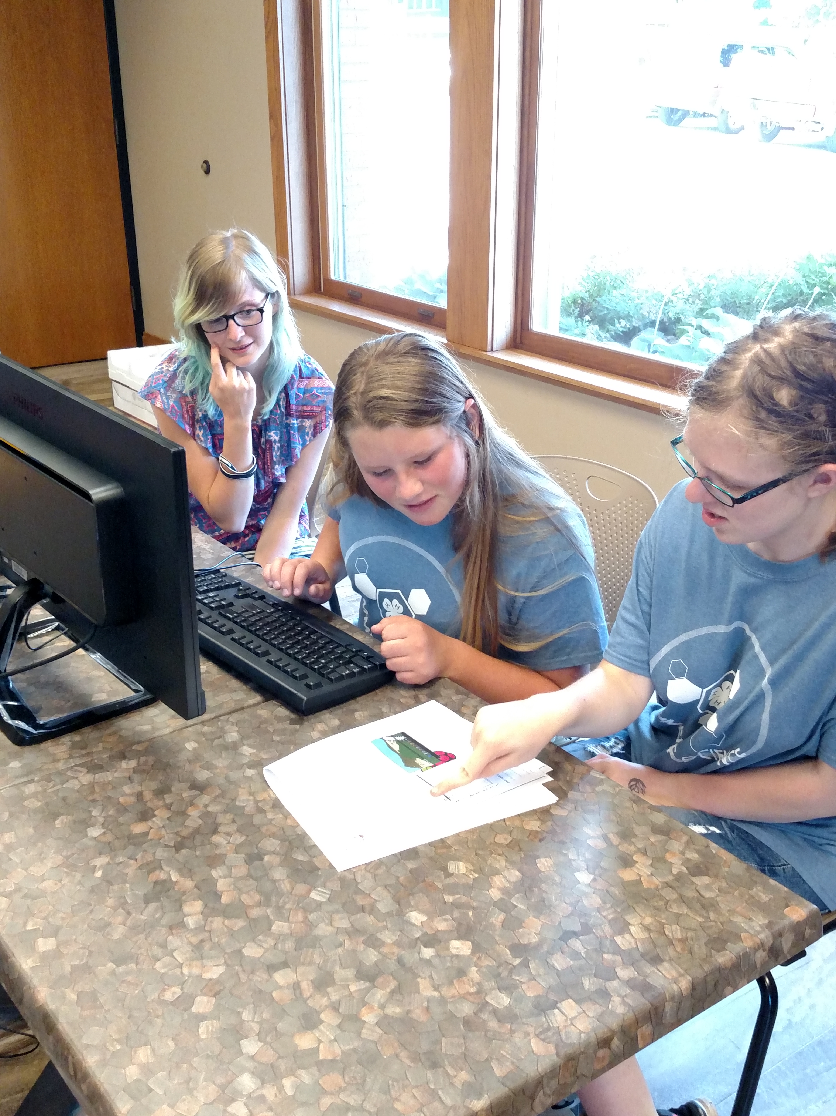
3 SOS Teen Leaders prepare themselves to help youth participants with the programming of Raspberry Pis.

4-H Summer Magic Camp
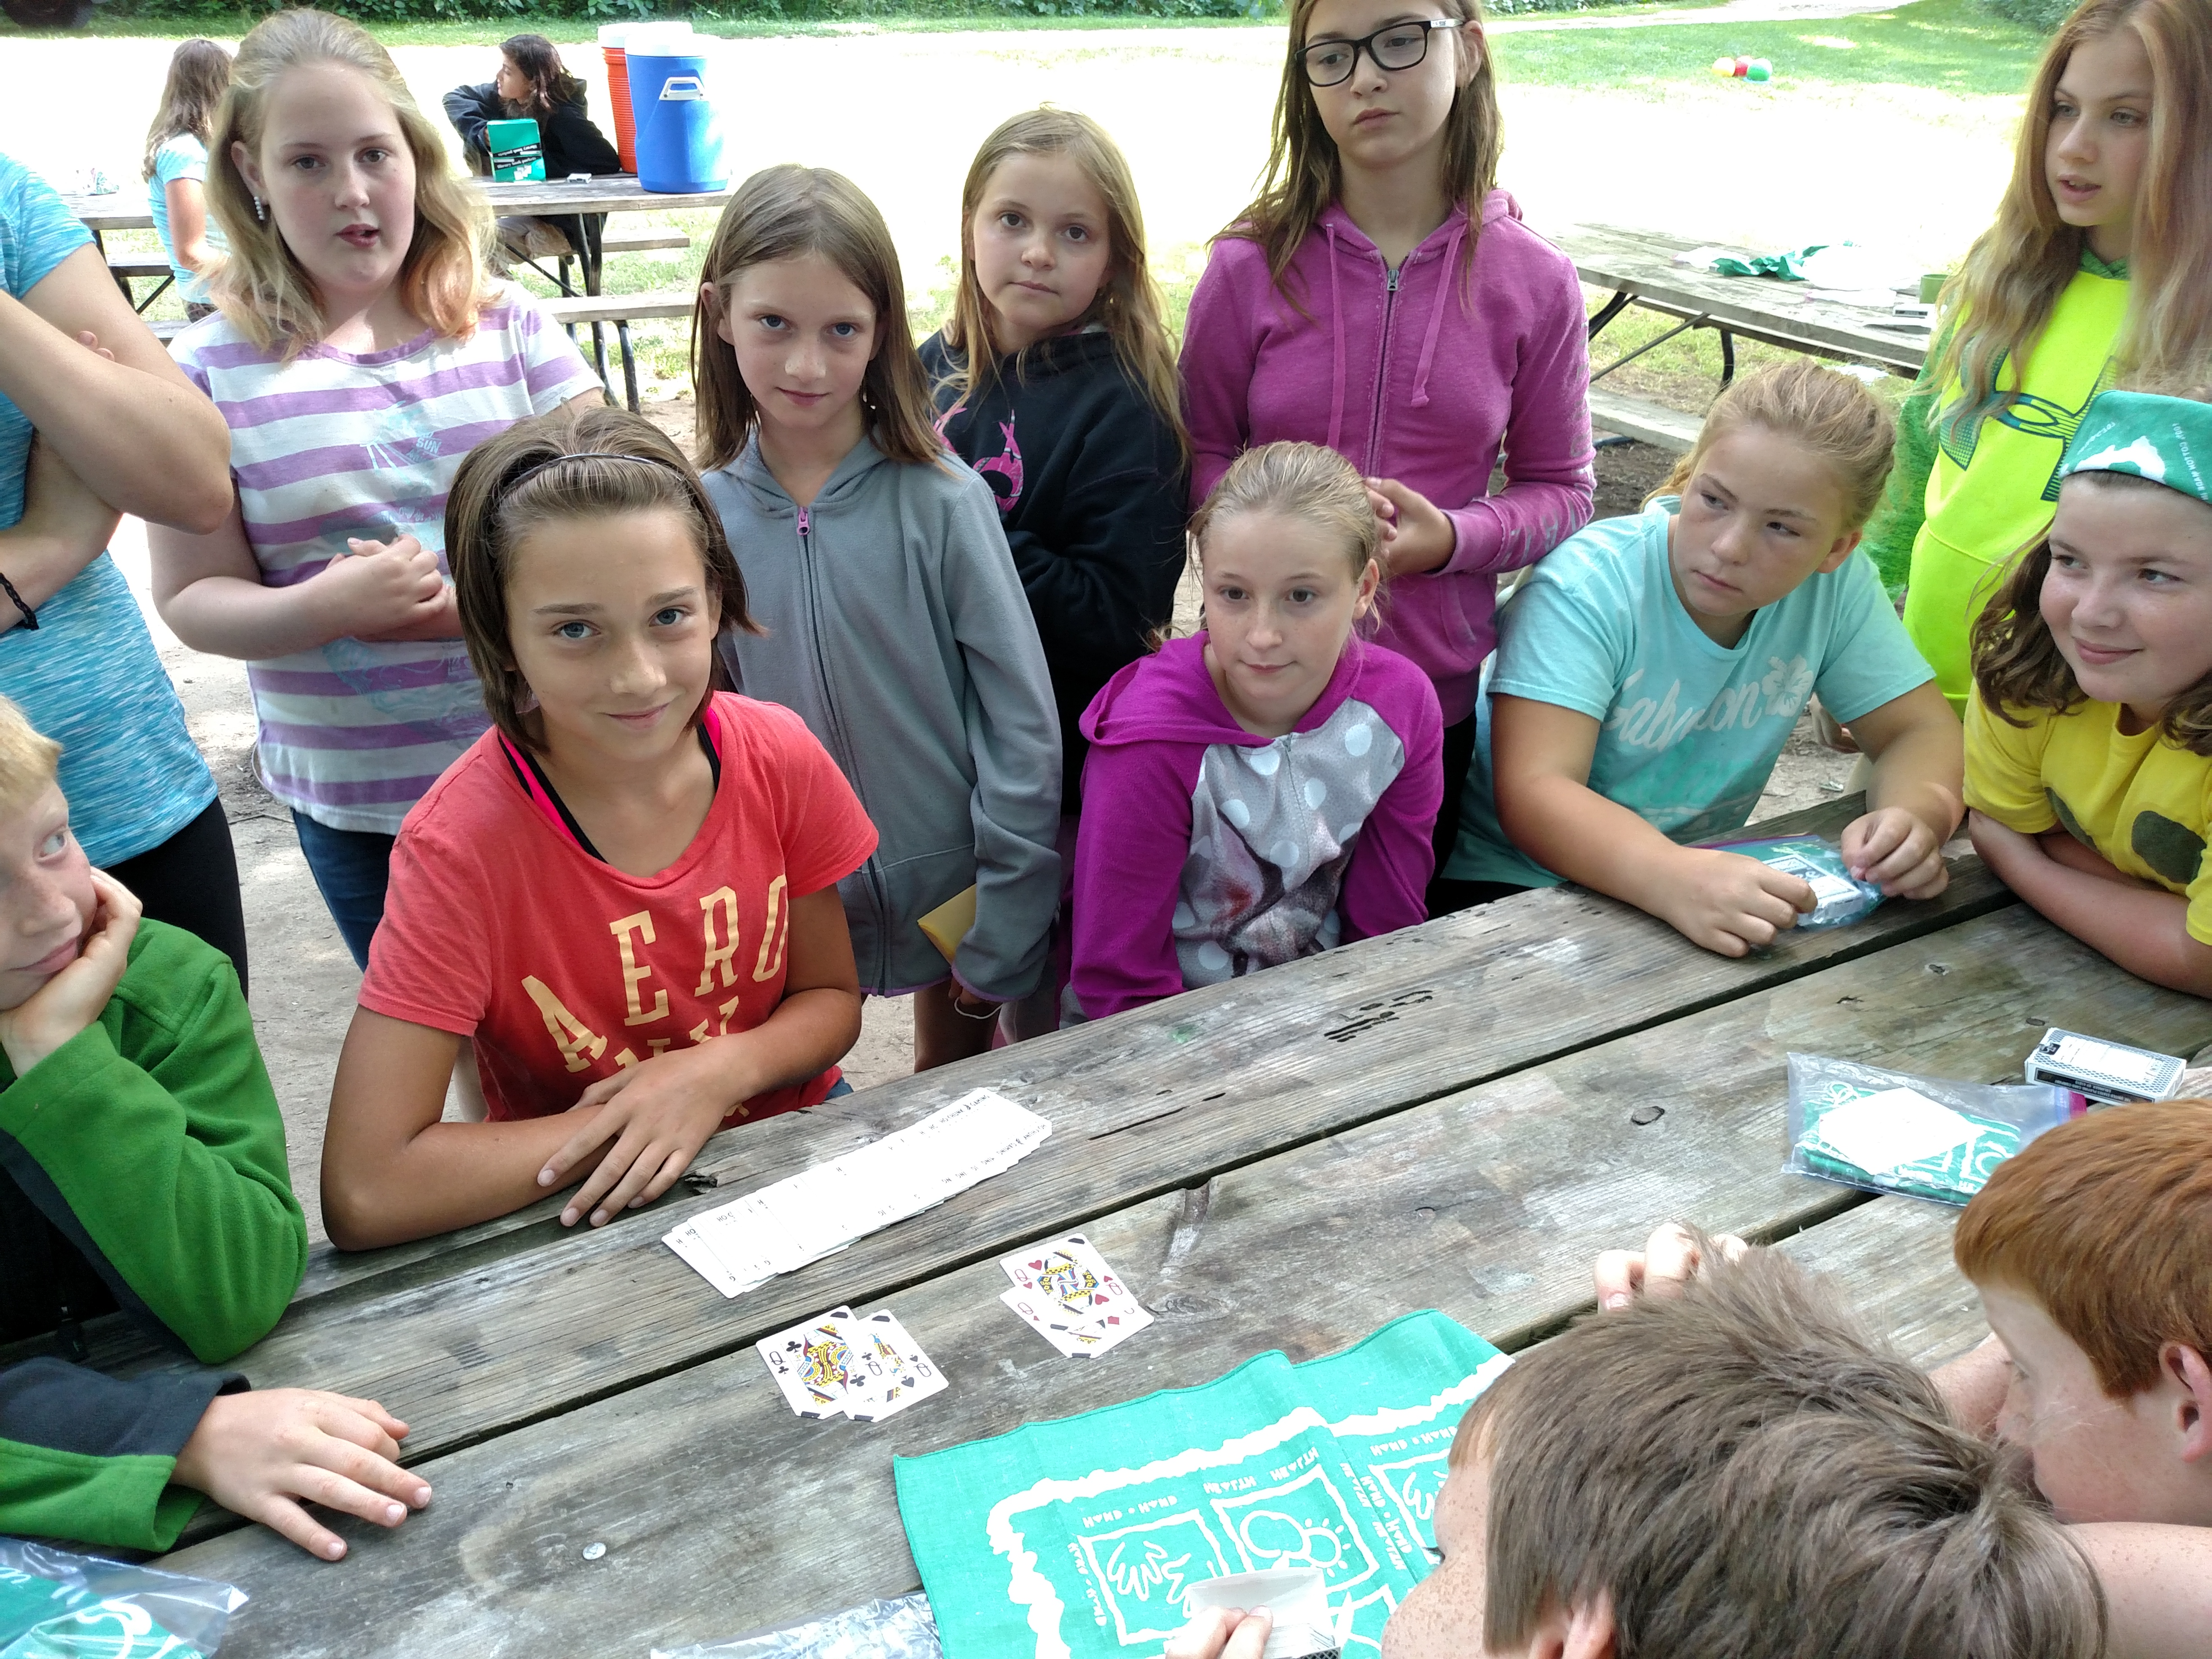
Jazmin Wagner, a camper, performs the 4 Queens trick she learned from the magician the previous day.

Cloverbud Camp
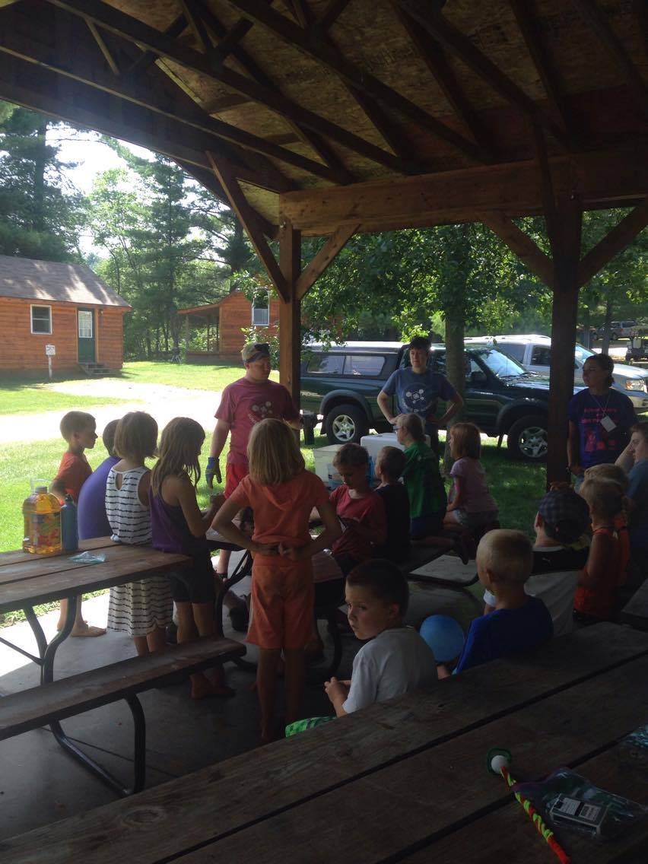
Alex Galston lead dry ice science experiments for the Cloverbud Campers.
August 2016 Highlights

4-H Outreach – Summer of Science Events:
- Raspberry Pi’s Technology Event – Adam Trunzo, Trempealeau County 4-H Youth Development Agent, came to Black River Falls to lead an educational event for youth in grades 7 and older to learn programming skills for mini-computers called Raspberry Pis.
- Reproductive Ultrasound – rescheduled due to the heat.
- Carcass Ultrasound – Held at the Fair and coordinated by the Livestock Education Committee with support from Trisha, the Carcass Ultrasound event had more than 20 youth and parents in attendance where the learned about when and how ultrasound technology can be used to assess the meat of a living animal.

Volunteer Development:
- Camp Counselor Training – 7 youth leaders spent 2 days being trained as Camp Counselors and Counselors-in-Training. They helped with planning and leading summer camp. They learned how to lead camp activities – including songs, science experiments, and magic tricks - and helped plan clues for a scavenger hunt for the campers. They also learned leadership skills such as communication, teamwork and decision-making.
- 4-H Summer Camp – 19 youth, the 7 camp counselors and CITs, 1 adult chaperon and 2 adult staff participated in 4-H magic-themed Summer Camp. The youth leaders led 9 science experiments during the course of the camp and also taught their activity groups magic tricks. The second day of camp included a professional magic show with the Cloverbuds and the third day of camp had the campers performing their own magic tricks for fellow campers. Everyone slept in tents, made s’mores around the campfire, and swam in the river, and through the camp, they learned skills of independence, teamwork, and communication.
- Cloverbud Camp – For 8 hours on Wednesday, July 13, 20 Cloverbud Campers took part in science activities that seem like magic, and they learned some “real” magic tricks. They made new friends, learned about their environment on a visit to Roaring Creek, and explored science in a fun, hands-on way.

Staffing:
- Stormie Brown started her 3rd summer (6 weeks) as the Summer Youth Work Experience Intern, through the Ho-Chunk Nation Department of Labor. Although primarily working for 4-H Youth Development, she has helped every single educator in the office with various projects and activities and will continue through the end of the month.

Fair:
- My tasks and responsibilities related to the Jackson County Fair are listed on the back of this page.

Key Meetings:
7/5 – Staff mtg
7/8 – Cloverbud Camp planning mtg.
7/11 – Powerful Tools for Caregivers mtg
7/18 – Help at 4-H Dairy Judge Contest; 4-H Executive Board mtg
7/27 – Ho-Chunk Nation CHIP Follow-Up mtg
7/28 – Powerful Tools mtg
8/9 – Task Force for Drug-Free Communities
8/12 – Together for Jackson County Kids Leadership Team
The majority of the month (after camp) was spent on fair preparations
Trainings/Workshops Facilitated/Led:
7/5 – Raspberry Pi’s Workshop
7/6-8 – Camp Counselor Training
7/12-14 – 4-H Summer Camp at Lost Falls Campground
7/13 – Cloverbud Camp
7/27 – Fair Clean-Up Night
8/3-7 – Jackson County Fair

Jackson County Fair – Major Responsibilities:
- Provide support to educational youth development opportunities throughout the year.
- Set up and maintain educational displays/activities in the ice arena related to 4-H and other youth development needs
- Act as superintendent of the Exploring Project and provide coordination and support for the Cloverbud Project.
- Provide extensive support to the 4-H Food Stand
- Provide support as needed throughout the fair in areas including horse, livestock, dairy, small animal, Round Robin, and herdsmanship awards
- Organize the Parade of Champions on Sunday afternoon of the fair
- Attend fair board meeting and/or communicate with the Fair Board as issues come up throughout the year.
- Answer exhibitors’ questions and provide support before, during, and after the fair
- Help with communication, set up, maintenance, and clean up after exhibits (including Junior Fair, Open Class, vendors, and nonprofit exhibitors) in the ice arena.
- Coordinate 4-H volunteers for arena supervision throughout fair.
- Help recruit superintendents and volunteers as well as provide support, troubleshooting, and education to superintendents and other volunteers before, during and after the fair
- Assist with coordination of the fair book changes annually
- Field a wide range of the public’s questions and concerns about the fair throughout the year.
- Help coordinate fair set up night – including promotion and recruitment of volunteers, working throughout set up night, support for the free 4-H food stand on clean up night and prep work to be ready for set up night.
- In collaboration with the Family Living Agent and the Fair Board member responsible for the ice arena, manage opening in the morning and closing in the evening as well as facility needs throughout the day.

